User Acceptance Testing (UAT) Template
Date | 19 February 2026
Team ID | LTVIP2026TMIDS77295
Project Name | Smart Sorting: Transfer Learning for Identifying Rotten Fruits and Vegetables.

Project Overview:
Project Name: Smart Sorting: Transfer Learning for Identifying Rotten Fruits and Vegetables.
Project Description: Smart Sorting is an AI-based image classification system that detects whether a fruit or vegetable is Fresh or Rotten using transfer learning. The system allows users to upload an image and receive a prediction with a confidence score.
Project Version: 1.0
Testing Period: 16 February 2026 to 19 February 2026
Testing Scope:
Features & Functionalities Tested:
- Image Upload
- Image Format Validation
- Model Prediction (Fresh/Rotten)
- Confidence Score Display
- Error Handling (No Image Uploaded)
- Dashboard Visualizations
- Filter Functionality
User Stories Tested:
- User can upload an image for classification.
- User can view prediction result with confidence score.
- User receives error message if invalid input is provided.
- User can filter dashboard results dynamically.
Testing Environment:
URL/Location: Google Colab / Local Web Application (Streamlit)
Credentials (if required): Not Required

Test Cases:
Test Case ID | Test Scenario | Test Steps | Expected Result | Actual Result | Pass/Fail
TC-001 | Upload valid image. | Step 1: Click upload  Step 2: Select JPG image  Step 3: Click Predict. | Image uploaded successfully and prediction displayed. | Prediction displayed correctly. | Pass
TC-002 | Upload invalid file format. | Step 1: Click upload  Step 2: Select PDF file  Step 3: Click Predict. | System should reject file and show error message. | Error message displayed. | Pass
TC-003 | Predict Fresh Image. | Step 1: Upload fresh fruit image  Step 2: Click Predict. | Output shows "Fresh" with confidence score. | Correct prediction shown. | Pass
TC-004 | Predict Rotten Image. | Step 1: Upload rotten fruit image  Step 2: Click Predict. | Output shows "Rotten" with confidence score. | Correct prediction shown. | Pass
TC-005 | No Image Uploaded. | Step 1: Click Predict without uploading image. | System should show validation error. | Alert message displayed. | Pass
TC-006 | Dashboard Filter Test. | Step 1: Select Fresh filter  Step 2: View updated graphs. | Dashboard updates dynamically. | Dashboard updated correctly. | Pass

Bug Tracking:
Bug ID | Bug Description | Steps to reproduce | Severity | Status | Additional feedback
BG-001 | Incorrect prediction for low-quality image. | Step 1: Upload blurred image  Step 2: Click Predict. | Medium | Closed | Model improved after fine-tuning.
BG-002 | Slow prediction on large image. | Step 1: Upload large image (>5MB)  Step 2: Click Predict. | Low | Closed | Image resizing implemented.

Outputs:
UI screenshots (Home, About, Predict, Result, Contact).
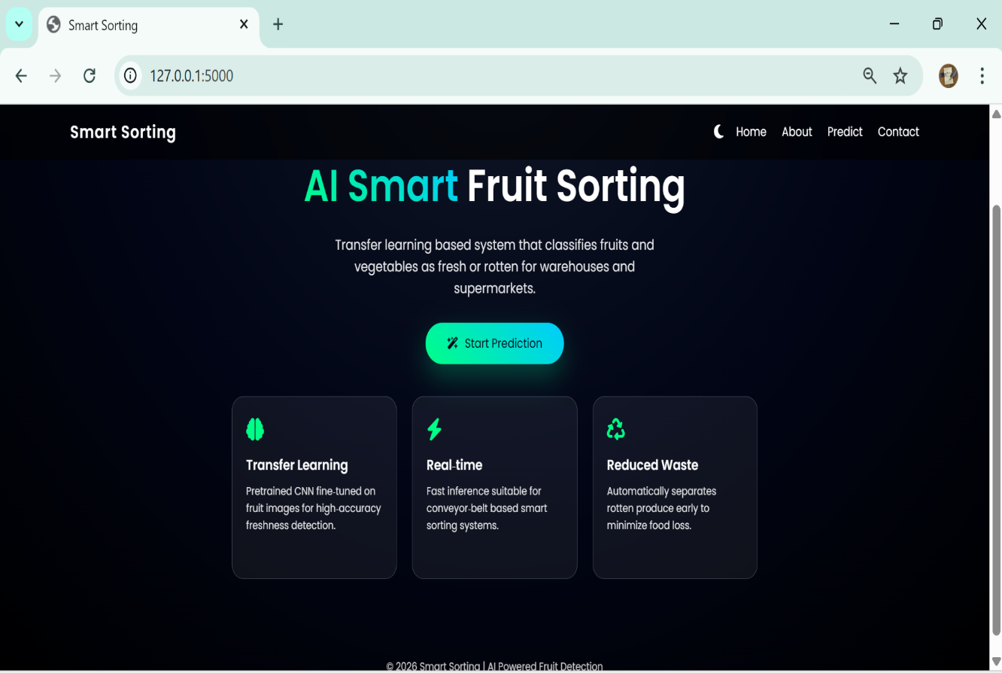
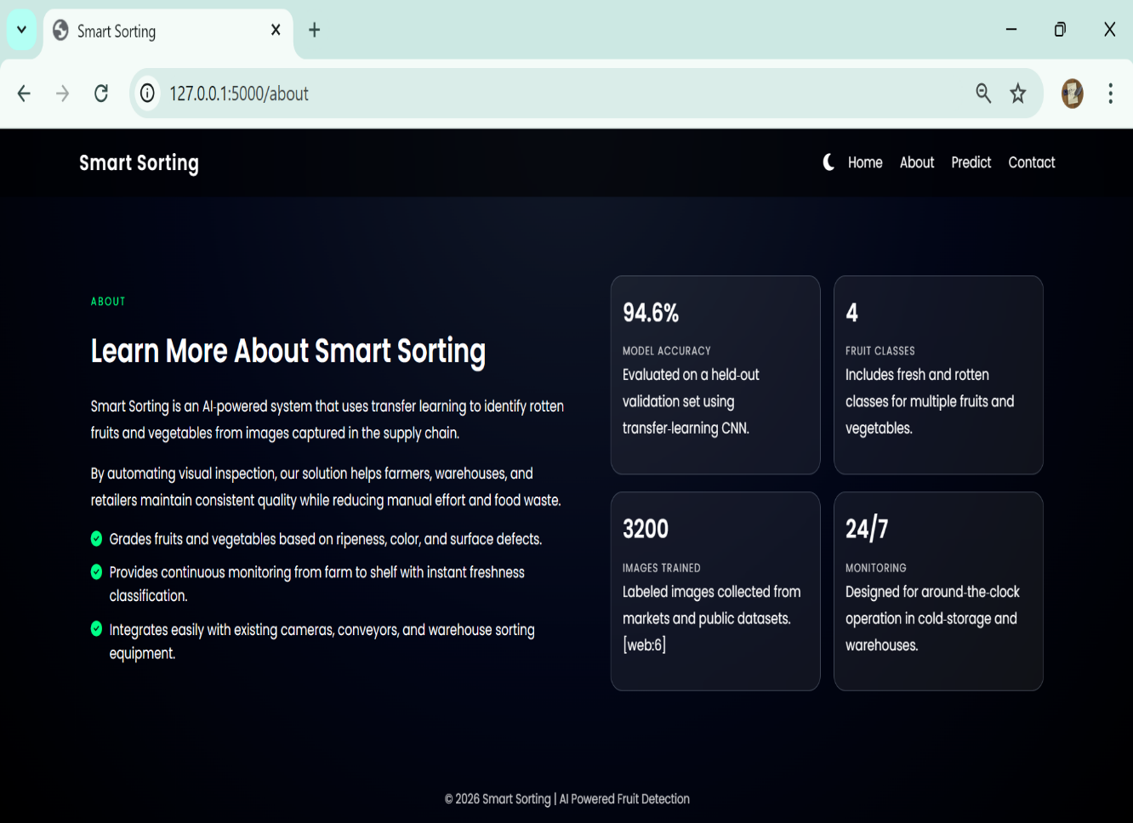
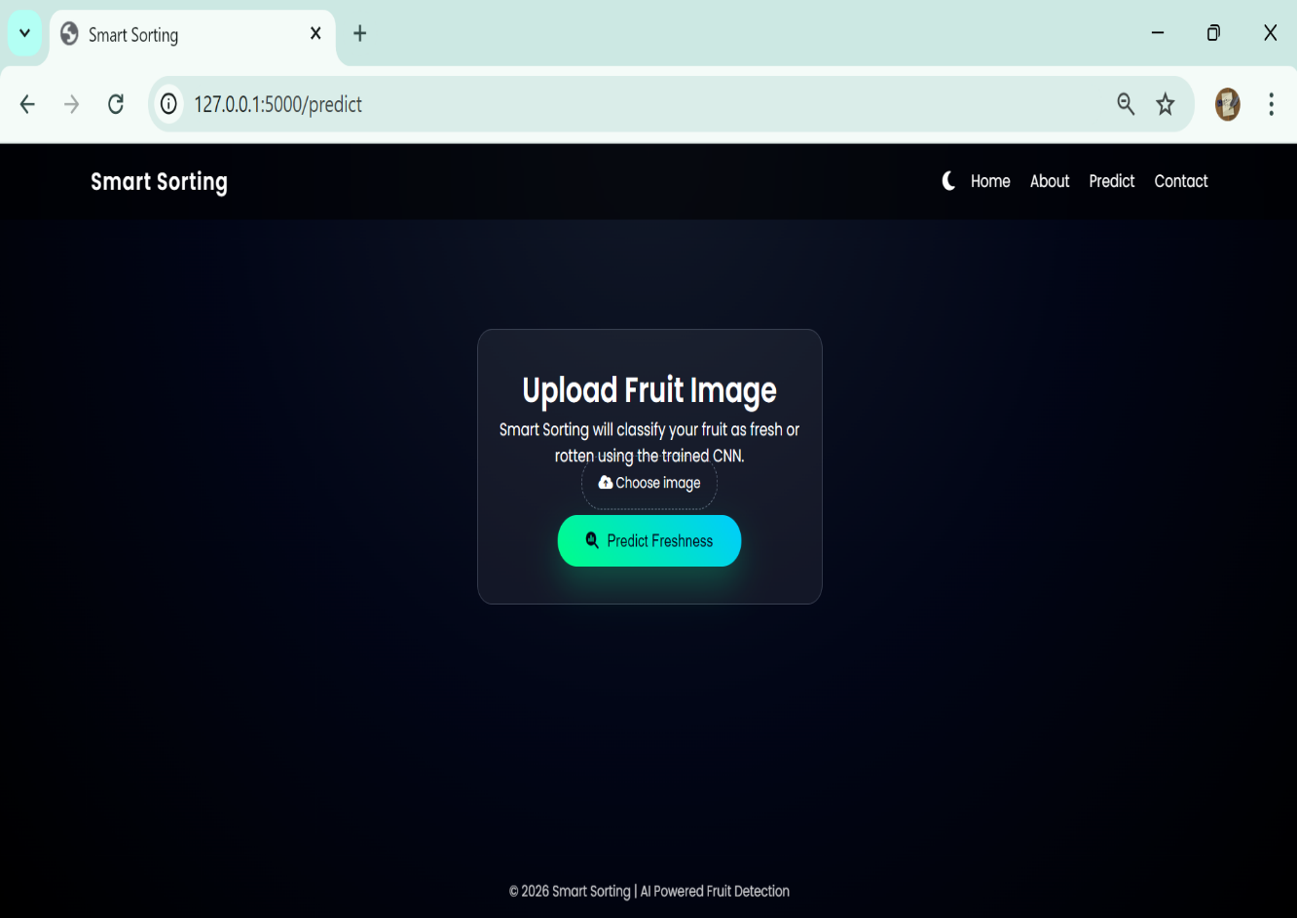
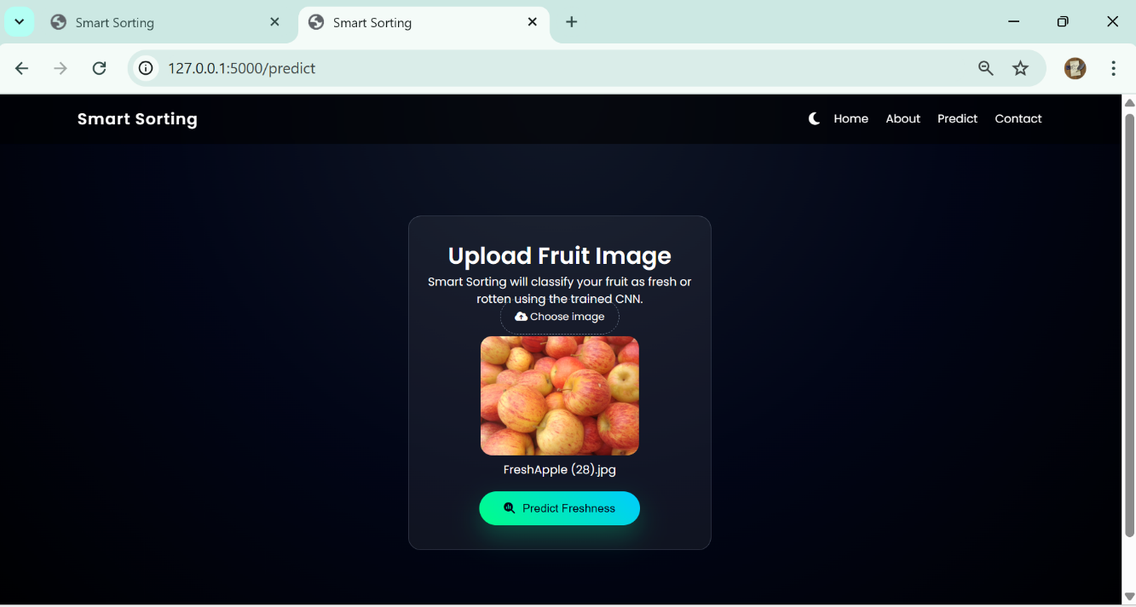
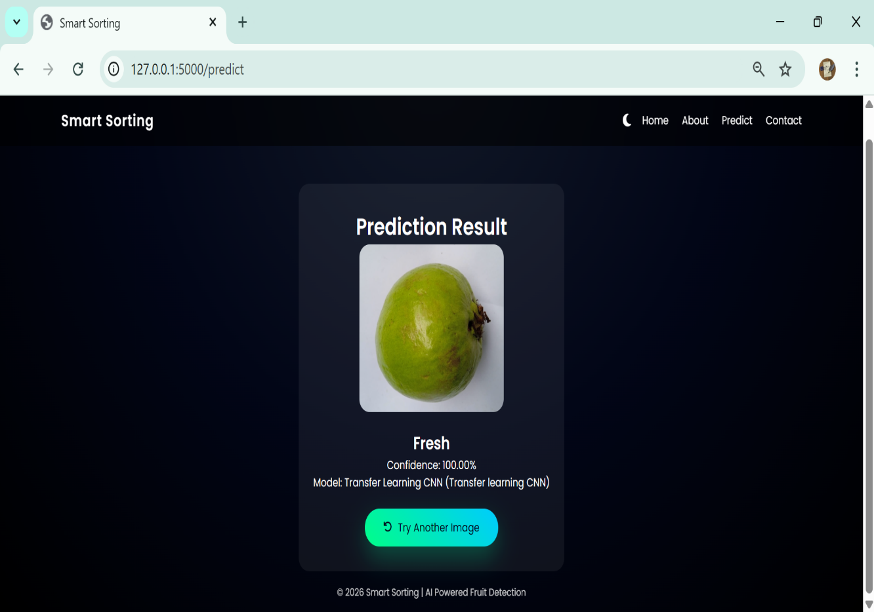

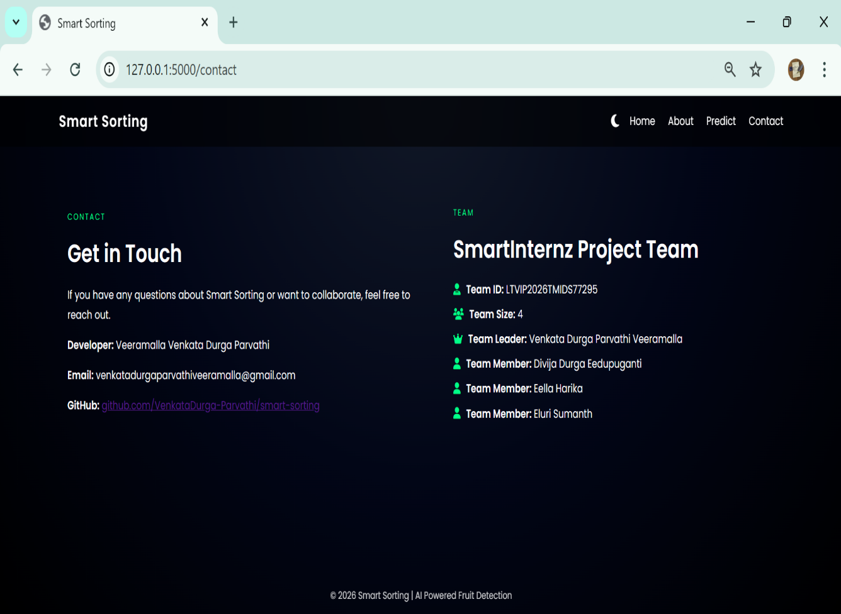
Confusion matrix and classification report:
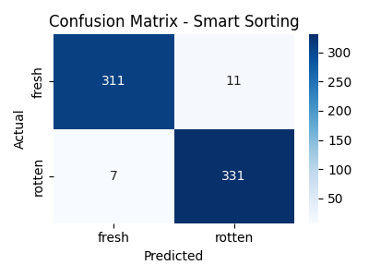

Tuned Accuracy Curve:
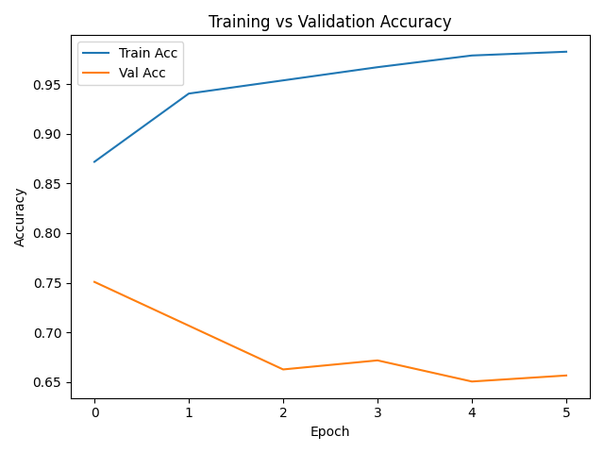
Tuned Loss Curve:
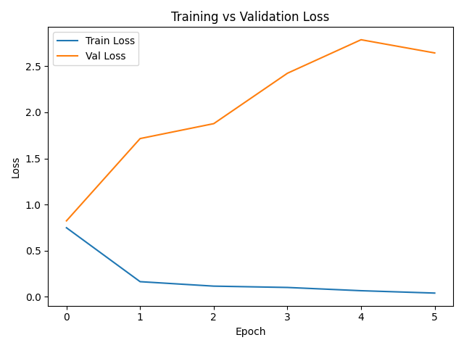
Burndown chart :
